Elongated Dancer Tuning and Simulation

Owen Lu

Electroimpact Inc.

owenl@electroimpact.com

*Abstract*—New mechanical modifications to the dancer design have allowed for greater stroke within the same footprint of the old design. This means that the gain can be reduced, allowing both lower torque and higher speed operation.

# Introduction

Although the servo creel system has shown to be far more consistent in tension control whilst running lower tension, the top speed is limited by the no-load speed of the motor. This is unlike the passive pneumatic system which requires the feed motor or machine axes to draw out material and only applies a drag torque to the system.

For very flat parts that do not require rapid direction changes while depositing material, the pneumatic system has the advantage since the stopping force is higher. The feasibility of this concept has been shown in linear speed testing, where speeds of up to 8000in/min on the TOP heads was achieved when depositing on tape. In the context of the creel, this test shows that the capabilities of the pneumatic system in high top speed may be sufficient.

In hopes to develop the servo creel system as a true next-generation machine, optimizations are considered in this paper to configure the system for both high speed and high acceleration operation.

# Mechanical Changes

The two main elements in the mechanical system that are under consideration are the reducer and the dancer. The reducer is straightforward as the series of gearboxes have multiple gearing ratios that are possible. For future generation heads instead of using a Wittenstein TP004, a custom Harmonic HPG-14 is under consideration. The reason is that multiple gearing ratios (7,8,9,10:1) are all possible whereas with the TP004 does not have those options. Both gearboxes have the necessary static moment load rating to support rapid C-axis acceleration.

The longer dancer stroke is the main mechanical change that allows for a lower reduction to be used. Since lower torque is necessary, the reduction is reduced subsequently extended the maximum speed of operation. The maximum rotational speed the input of the gearbox will see is calculated below in Eq. 1.

|  |  |
| --- | --- |
| $$ω_{max}=G\left(\frac{v_{max}}{πd_{min}}\right)$$ | (1) |

For the spools used, the minimum diameter is $3.5in$. In this case, we are considering a 8:1 reduction with 5500in/min max speed.

$$ω_{max}=8\left(\frac{5500}{3.5}π\right)=4000rpm$$

Empirically, through a 10:1 reducer 4000rpm is consistently achievable on the SM23166MT motors. This is why 8:1 reduction will be used as a starting point for simulation.

# Calculation of control constants

From a previous paper, in Figure 1 we have the switching controller structure. The structure switches from a single feedback loop to two feedback loops to increase the gain of the system. It can essentially be modeled as a 2 DOF controller with two unity gain paths.

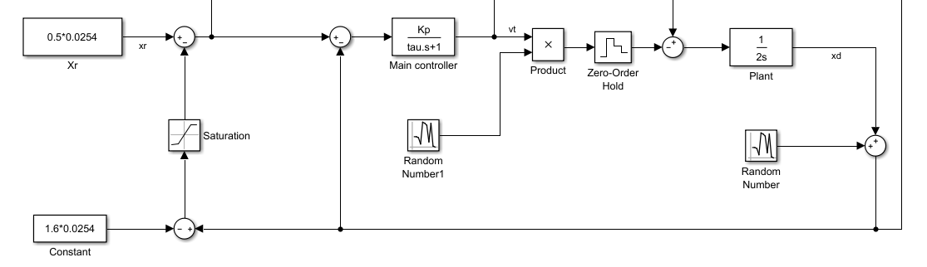

Figure - Switching controller structure

The steady-state displacement is written in Eq. 2.

|  |  |  |
| --- | --- | --- |
|  |  | () |

The key to calculating steady-state displacement is to first find the region which the controller is operating.

The main variables that are important to calculating an appropriate threshold to switch are the material addition speed, controller gain, and the reference point.

The control regime is separated into two modes, high and low-speed operation. What defines high and low speed is mainly the initial material addition speed. In order to reduce the torque demands we want a small gain to existing during this process and therefore the threshold has to be above the steady-state displacement that is caused by the maximum addition speed.

|  |  |
| --- | --- |
| $$x_{t}>x_{r}+\frac{v_{i}}{K_{e}}$$ | (3) |
| $$v_{i}=2000in/min$$ | (4) |

In general $x_{r}$ is the initial displacement of the dancer and therefore also sets the initial tension. In practice, values around 0.1in are good values since small oscillation will not cause any lost tension.

At this point, we can set the $x_{ss}$ to be the value of the maximum dancer travel we wish to allow. Keep in mind the control structure has a damping constant to guarantee no overshoot during the process. Therefore, setting this to the maximum “safe” value off the top of the dancer stroke is done. In this case we,, use a value of 4.25in.

|  |  |
| --- | --- |
| $$x_{ss}=4.25in$$ | (5) |
| $$v_{o}=5500in/min$$ | (6) |

The calculation is then done to minimize the gain under the Equations 1-5.

We can simplify the calculation by setting $x_{t}=x_{r}+\frac{v_{i}}{K_{e}}$

|  |  |
| --- | --- |
| $$x_{ss}=\left(x_{r}+\frac{1}{2K_{e}}\left(v_{i}+v_{o}\right)\right)$$ | (7) |
| $$K_{e}=\frac{1}{2}\frac{v_{i}+v_{o}}{\left(x_{ss}+x_{r}\right)}=14.5rad/s$$ | (8) |

Eq. 6 gives the optimal gain with the threshold assumption made. Note that this is not optimal in a traditional optimal control sense since penalty equation was made. This simply allows low torque and high-speed operation within the dancer stroke.

# Simulation profile

In order to test both acceleration performance and top speed performance the spars simulation previously used to test the torque requirements of the motor is used. Instead, however, the target speed is 5500in/min. This is approximately 50% faster than the top speeds of current spars machines and is a good starting point since it is likely that other parts of the system such as the heater may bottleneck performance.

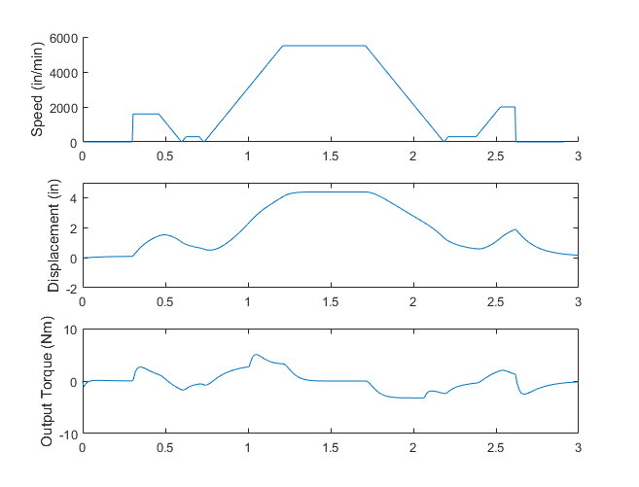

Figure 2 - Modified payout speed profile

The simulation shows that the torque required at the output during acceleration is maximum at 5Nm and is significantly less than the 7.2Nm max for the SM23166MT at the 1000rpm operating point of operation.

# Conclusion

Initial simulation shows that the torque speed curve of the SM23166MT combined with a 8:1 reducer (versus currently 10:1) is sufficient to run 8.5 inch diameter spools at a top speed of 5500in/min. This means that with the exact same control architecture within the motor, and the exact same commands from the PLC can be used in a seamless way. The only difference is that the software loaded onto the SmartMotor initially will have different control constants.

Thus, the servo creel can likely be used for different aircraft parts appropriately reaching extremely high top speeds whilst maintaining the ability to accelerate at the rate of the machine acceleration.